***NAME: RAHUL GOEL  
REG NO : RA1911030010094***

***SEC: O2***

**AIM:**  
To design and implement carry look ahead adder.

**Software used:**  
Logic Gate Simulator

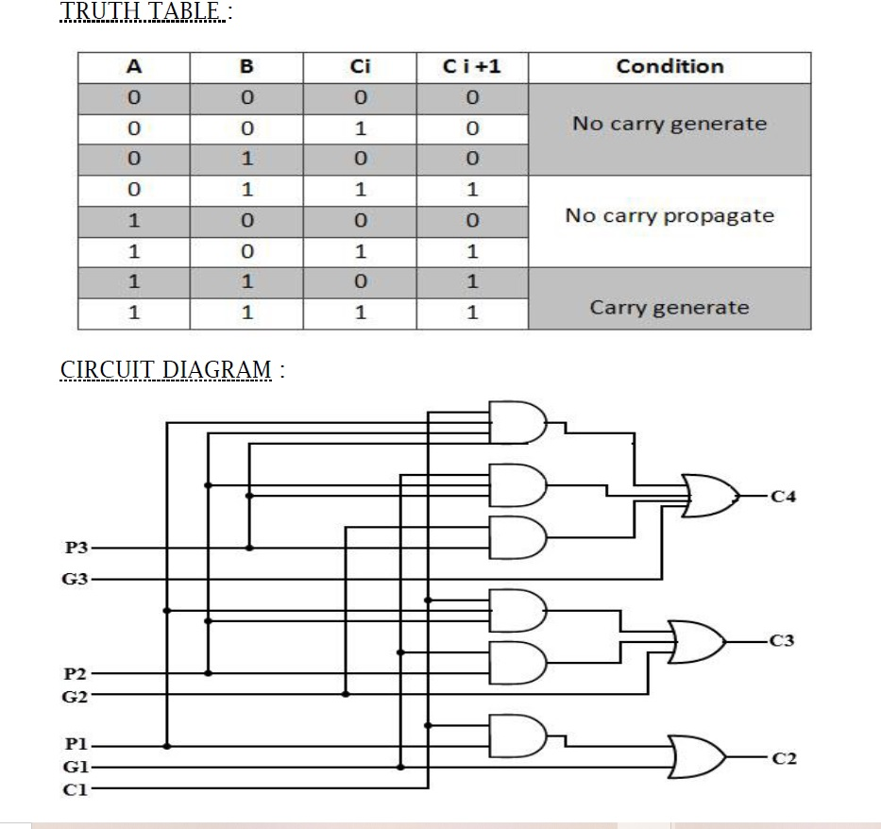

**IC:**  
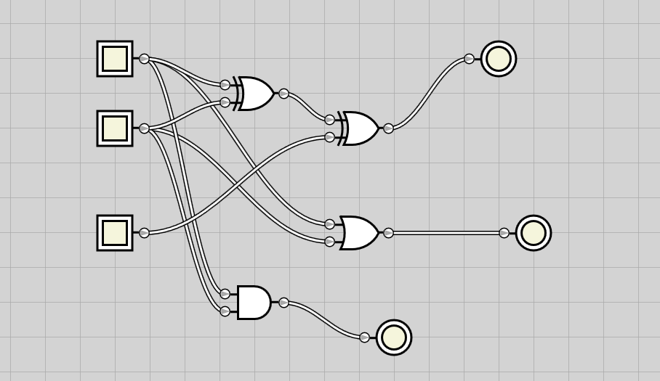

**Circuit:**  
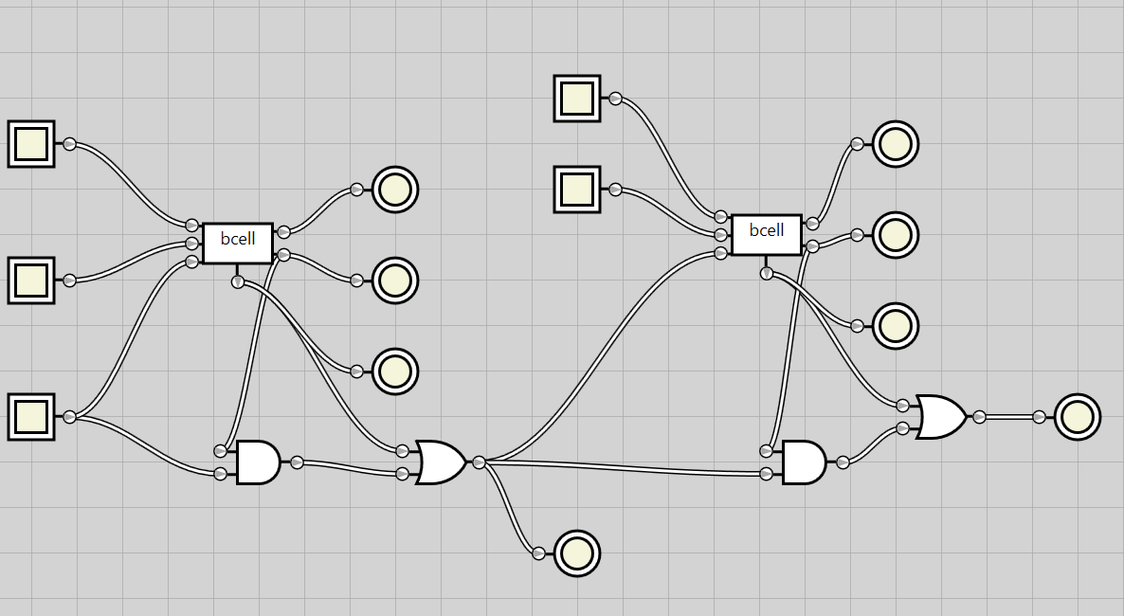  
**Output:**  
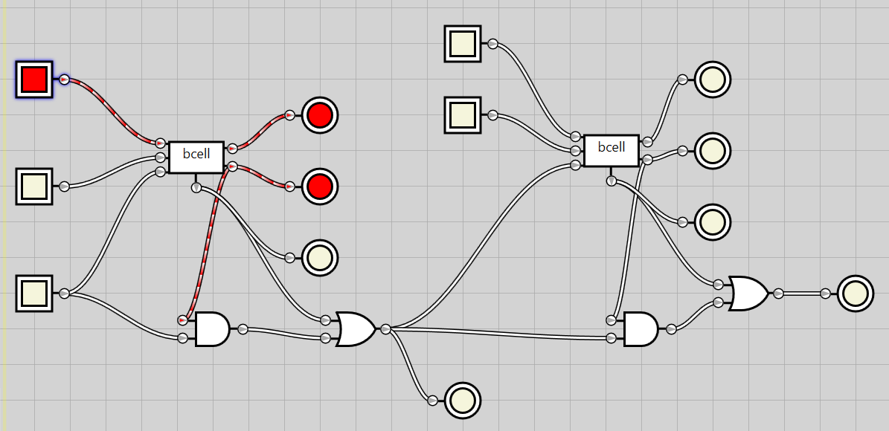

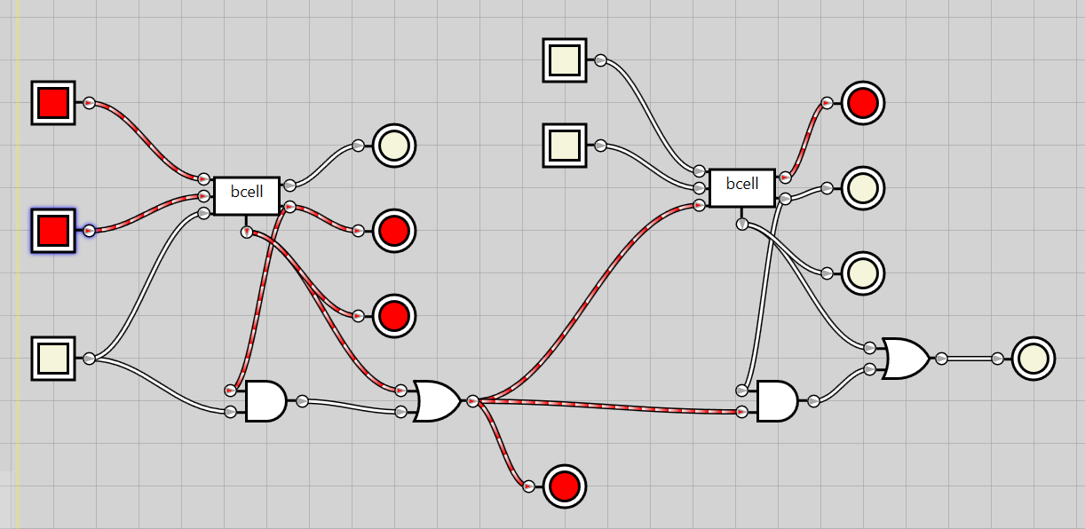

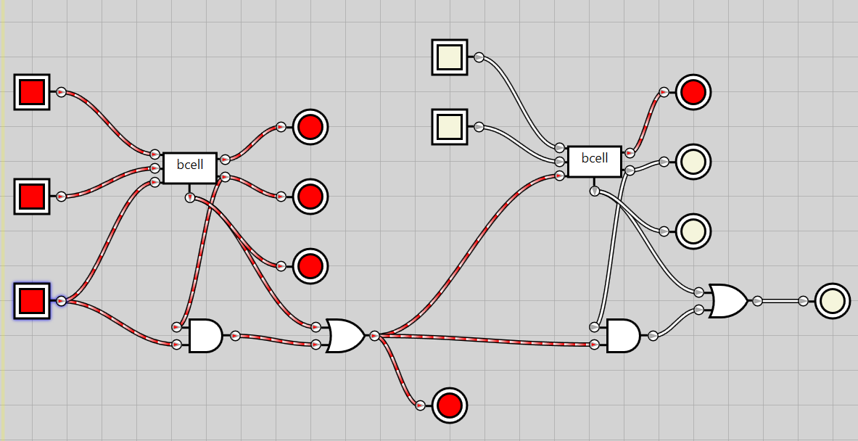

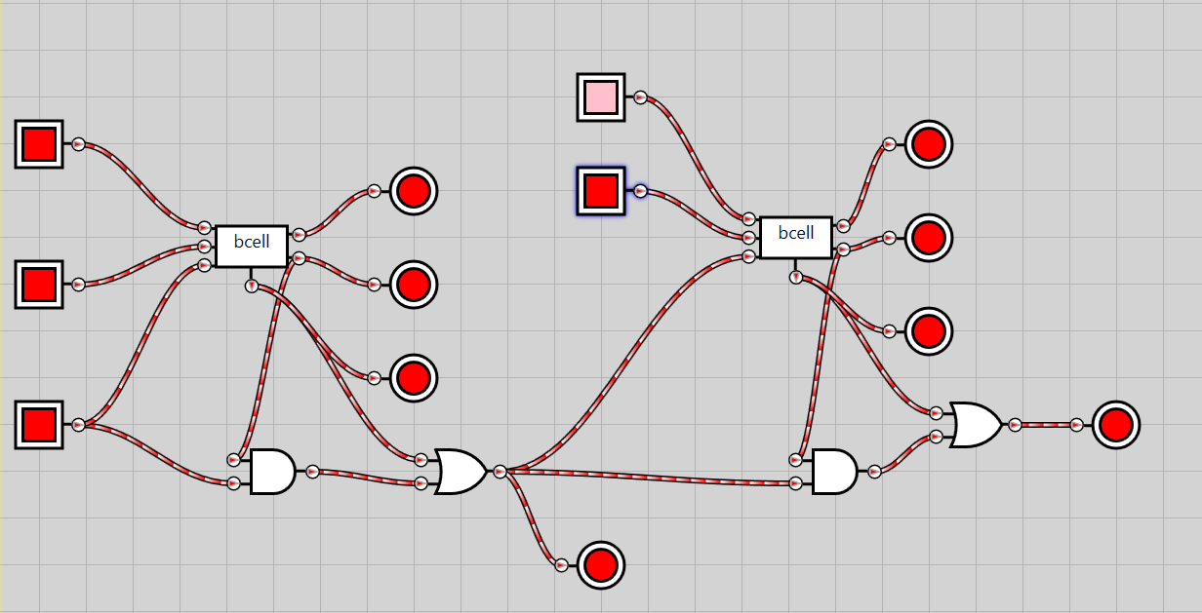

**Result:**

we have successfully designed a carry look ahead adder and seen its implementation using logic gate simulator